**Lab – 23:** **Turn on Fraud Alert in the Azure portal.**

**Objective:** The objective of this lab is –

* To turn on Fraud Alert in the Azure portal.

Fraud alert can be configured and set up so that your users can report fraudulent attempts to access their resources. Users can report fraud either with the mobile app or through their phone.

**Prerequisite:** EMS Enterprise Mobility + Security E5.

**Steps:**

1. Sign in to your Azure Portal, by using the link - **https://portal.azure.com/**. Enter your credentials and click Sign In.

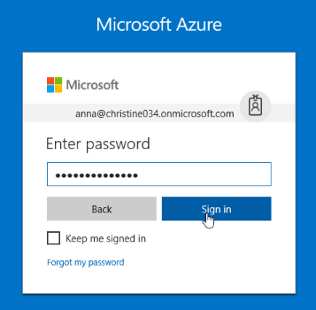

1. Microsoft Azure AD Dashboard will open.

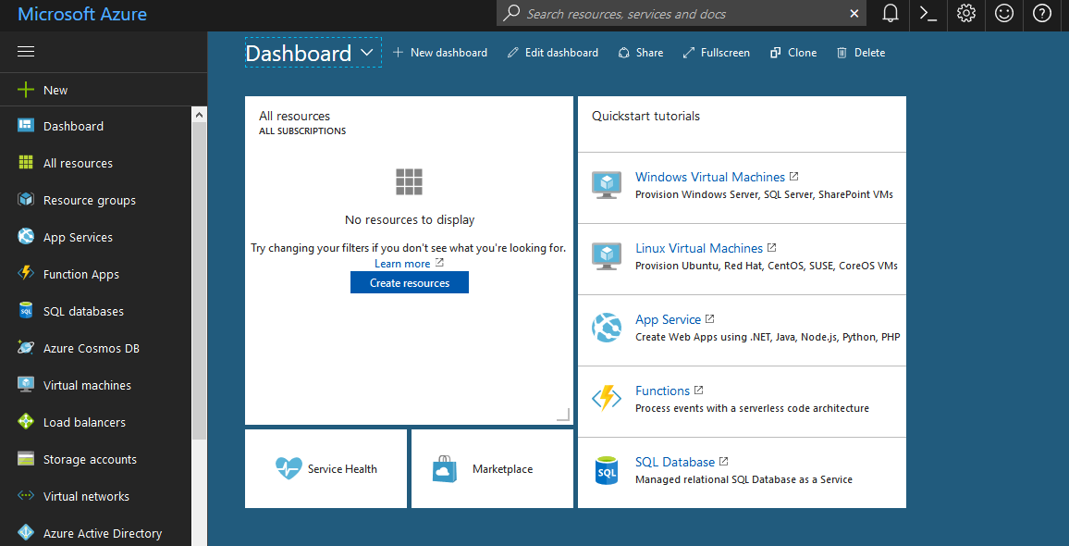

1. Navigate to **Azure Active Directory** > **MFA Server** > **Fraud alert**. Allow your users to report fraud if they receive a two-step verification request that they didn't initiate.
2. Turn **Allow users to submit fraud alerts** to **On**. Turning on will allow users to reports fraud if they will receive any two-step verification request that they didn’t initiate.

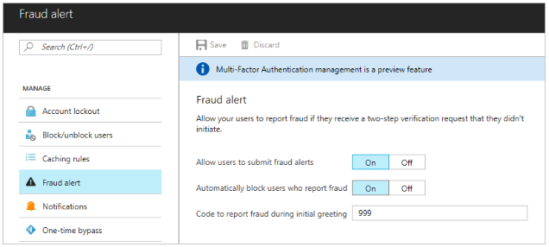

1. Automatically block users who report fraud, keep it turn on as default.
2. Then click **Save**.
3. So, in this way, you can turn on Fraud Alert in the Azure portal.